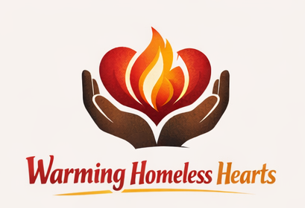
Many Sleeping Bags. Many Lives Changed
June 2026
Warming Homeless Hearts is a local nonprofit helping people who are homeless stay warm and feel cared for. We collect sleeping bags and other important supplies and give them directly to those in need, working closely with local groups and volunteers.
Our mission is to bring together businesses, schools, volunteers, and donors to quickly help people facing homelessness. We also work to teach the community about the challenges of homelessness and ways to help.
Last winter, we gave out over 100 sleeping bags to people who needed them most. Homelessness doesn’t stop when winter ends—many people still need help in spring, summer, and fall. Some move from city to city, while others have found a place to stay in Greenfield. We want to make sure everyone has a sleeping bag year-round. Right now, you can drop off sleeping bags at Freedom Café in Greenfield, MA, our partner who also offers other support to those experiencing homelessness.
This winter, we officially became a registered nonprofit with 501(c)(3) status. We also launched our new website this spring: warminghomelesshearts.org.
We need your help to keep going. We welcome donations of money or supplies, and we’re always looking for new volunteers to join our team.
We extend our heartfelt gratitude to all of our dedicated and hardworking volunteers. Your compassion, energy, and commitment are the heart of Warming Homeless Hearts, and we simply could not carry out our mission without you. Thank you for making a real difference in the lives of our neighbors.

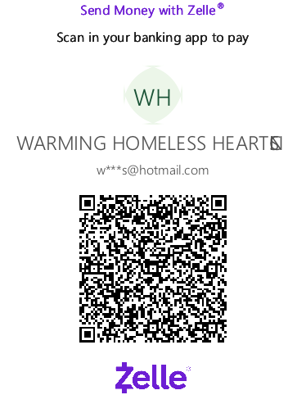
Where Warmth Meets Humanity
We thank you for your donation.
Heather Carmichael, Founder, Visionary

